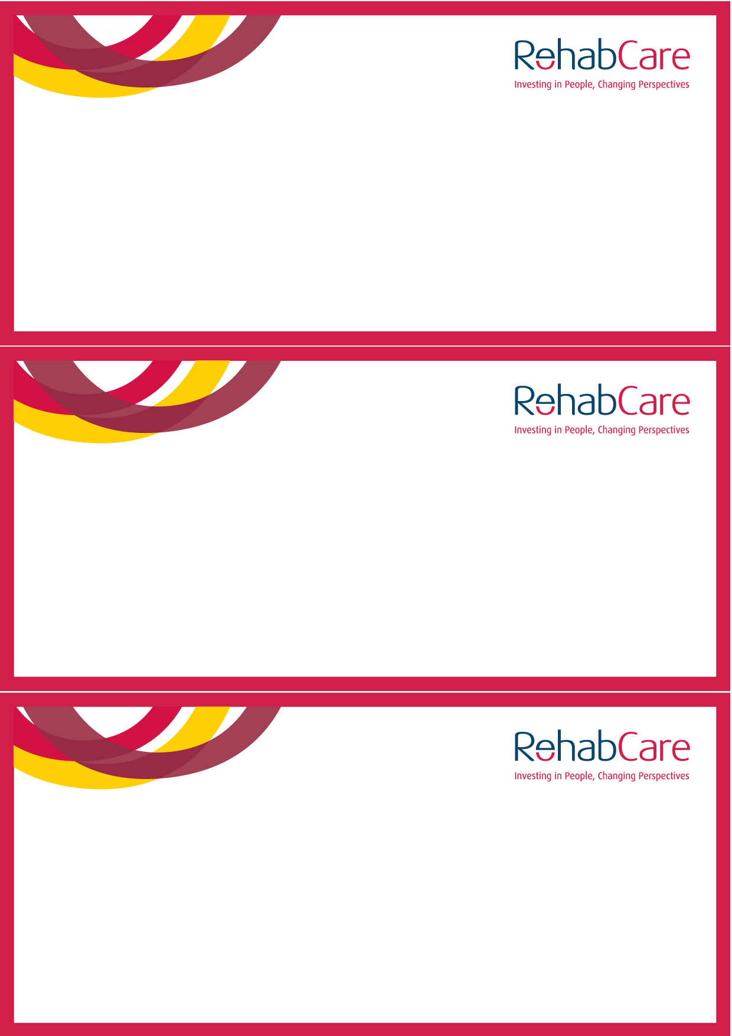

You are cordially invited to the official launch of

**The Meadow’s Childrens’ Respite Service**

**By RTÉ’s Miriam O’ Callaghan**

on Wednesday, 5th October 2011 at 12pm

The Meadows, Philpottstown, Trim Road, Navan, Co. Meath

RSVP to Louise Tinne, tel: 046 9076629 or [louise.tinne@rehabcare.ie](mailto:louise.tinne@rehabcare.ie)

before Friday, 30th September 2011

You are cordially invited to the official launch of

**The Meadow’s Childrens’ Respite Service**

**By RTÉ’s Miriam O’ Callaghan**

on Wednesday, 5th October 2011 at 12pm

The Meadows, Philpottstown, Trim Road, Navan, Co. Meath

RSVP to Louise Tinne, tel: 046 9076629 or [louise.tinne@rehabcare.ie](mailto:louise.tinne@rehabcare.ie)

before Friday, 30th September 2011

You are cordially invited to the official launch of

**The Meadow’s Childrens’ Respite Service**

**By RTÉ’s Miriam O’ Callaghan**

on Wednesday, 5th October 2011 at 12pm

The Meadows, Philpottstown, Trim Road, Navan, Co. Meath

RSVP to Louise Tinne, tel: 046 9076629 or [louise.tinne@rehabcare.ie](mailto:louise.tinne@rehabcare.ie)

before Friday, 30th September 2011